05/10/13

CAP 222

Specialization Field - Modeling

Plan of Instruction

Effective Date: Spring 2013 Version Number: 2013-1

COURSE DESCRIPTION:

This course furthers the study of a particular field (modeling or animation) chosen by the student. Topics include (for modeling) digital sculpting, further anatomical study, understanding of muscle, fat and bone structure. Topics for animation include, learning of motion capture software, roto-capture and animation projects. Upon completion, the student should be able to showcase a deeper understanding of his chosen field.

CONTACT/CREDIT HOURS

Theory Credit Hours 1 hour
Lab Credit Hours 2 hours
Total Credit Hours 3 hours

NOTE: Theory credit hours are a 1:1 contact to credit ratio. Colleges may schedule lab hours as manipulative (3:1 contact to credit hour ratio) or experimental (2:1 contact to credit hour ratio).

PREREQUISITE COURSES

None

CO-REQUISITE COURSES

As determined by college.

PROFESSIONAL COMPETENCIES

- Use advanced techniques for organic modeling.
- Utilize CGI modeling skills on a CGI auto portrait project.

INSTRUCTIONAL GOALS

- Cognitive – Comprehend principles and concepts related to advanced animation or modeling.

- Psychomotor – Apply principles of advanced animation or modeling.

- Affective – Value the importance of understanding advanced animation or modeling.

STUDENT OBJECTIVES

Condition Statement: Unless otherwise indicated, evaluation of student’s attainment of objectives is based on knowledge gained from this course. Specifications may be in the form of, but not limited to, cognitive skills diagnostic instruments, manufacturer’s specifications, technical orders, regulations, national and state codes, certification agencies, locally developed lab/clinical assignments, or any combination of specifications.

STUDENT LEARNING OUTCOMES

MODULE A – MODELING FIELD: ORGANIC MODELING
MODULE DESCRIPTION – This module instructs students on notions associated with advanced techniques for organic modeling. Topics include the philosophy of organic modeling, volume study, proportions, volume blocking, using photographic references, Mudbox software, details and thickness, organic modeling techniques of the Edge Flow approach.
PROFESSIONAL COMPETENCIES | PERFORMANCE OBJECTIVES | KSA
A1.0 Use advanced techniques for organic modeling. | A1.1 Create a CG hand and a CG boulder to demonstrate accurate volume modeling. | 3
LEARNING OBJECTIVES |  | KSA
A1.1.1 Explain character modeling philosophy.  A1.1.2 Describe the techniques necessary to model accurate volume when creating a CG hand.  A1.1.3 Describe the techniques necessary to model accurate volume when creating a CG boulder.  A1.1.4 Explain the importance of faithful proportions and how to rely on photographic references.  A1.1.5 Describe Mudbox software workflow.  A1.1.6 Discuss a case study emphasizing details and object thickness.  A1.1.7 Explain the preponderance of the edge flow approach with various case studies (eye, nose and ear).  A1.1.8 Describe Sculptris software workflow. |  | 3  3  3  4  3  3  4  3
MODULE A OUTLINE:
- Organic modeling philosophy
- Volume study I: The human hand
- Volume study II: The boulder
- Proportions study and volume blocking
- Using photographic references
- Mudbox software
- Case study: Details and thickness
- Organic modeling techniques: Edge flow
  - The eye
  - The nose
  - The ear
- Volume study III: Sculptris Software.

MODULE B – MODELING FIELD: AUTO PORTRAIT
MODULE DESCRIPTION – This module allows students to hone their modeling skills on a CGI auto portrait project. Topics include reference preparation, volume blocking, detailing, edge flow, third party evaluation, and final presentation.
PROFESSIONAL COMPETENCIES | PERFORMANCE OBJECTIVES | KSA
B1.0 Utilize CGI modeling skills on a CGI auto portrait project. | B1.1 Create and revise a CGI human head demonstrating accurate proportions, volume blocking, edge flow, and presentation techniques. | 4
LEARNING OBJECTIVES |  | KSA
B1.1.1 Explain the need for collecting a sufficient amount of photographic references.  B1.1.2 Describe the techniques necessary for accurate proportions and volume blocking.  B1.1.3 Explain the level of details needed for accuracy.  B1.1.4 Discuss advanced edge flow techniques.  B1.1.5 Explain the necessity of responding to third party requests and revising the CG model accordingly.  B1.1.6 Describe the shading material and turntable animation techniques used to present the final object. |  | 4  4  3  4  4  3
MODULE B OUTLINE:
- Reference preparation
- Volume blocking
- Detailing
- Edge flow outline
- Third party evaluation
- Preparing the model for final presentation

LEARNING OUTCOMES Table of specifications
The table below identifies the percentage of learning objectives for each module. Instructors should develop sufficient numbers of test items at the appropriate level of evaluation.

 | Limited Knowledge and Proficiency | Moderate Knowledge and Proficiency | Advanced Knowledge and Proficiency | Superior Knowledge and Proficiency
KSA | 1 | 2 | 3 | 4
Module A |  |  | 75% | 25%
Module B |  |  | 33% | 66%

The KSA is NOT determined by the verb used in the learning objective, but rather in the context in which the verb is used and the depth of knowledge and skills required.

Example: Three KSA levels using the same verb (describe):
KSA 1 – Describe three characteristics of metamorphic rocks. (simple recall)
KSA 2 – Describe the difference between metamorphic and igneous rocks. (requires cognitive processing to determine the differences in the two rock types)
KSA 3 – Describe a model that you might use to represent the relationships that exist within the rock cycle. (requires deep understanding of rock cycle and a determination of how best to represent it)
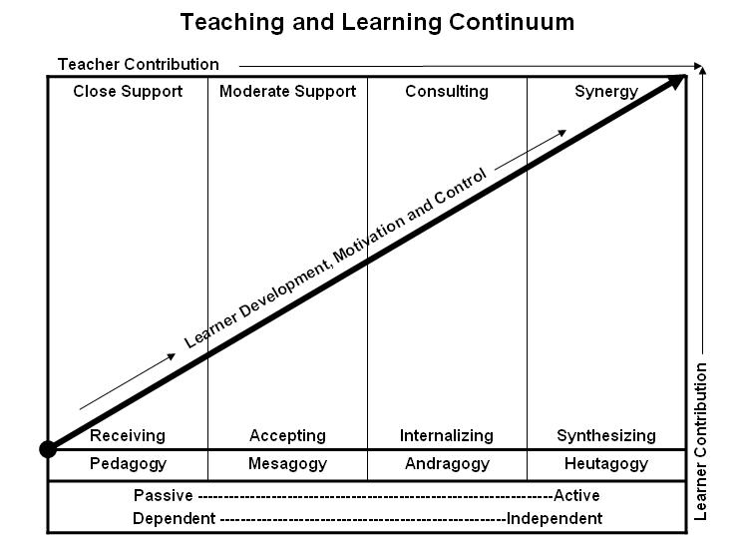
Learner’s Knowledge, Skills and Abilities
Indicator | Key Terms | Description
1 | Limited Knowledge and Proficiency | - Recognize basic information about the subject including terms and nomenclature.  - Students must demonstrate ability to recall information such as facts, terminology or rules related to information previously taught.  - Performs simple parts of the competency. Student requires close supervision when performing the competency.
2 | Moderate Knowledge and Proficiency | - Distinguish relationships between general principles and facts. Adopts prescribed methodologies and concepts.  - Students must demonstrate understanding of multiple facts and principles and their relationships, and differentiate between elements of information. Students state ideal sequence for performing task.  - Performs most parts of the competency with instructor assistance as appropriate.
3 | Advanced Knowledge and Proficiency | - Examines conditions, findings, or other relevant data to select an appropriate response.  - The ability to determine why and when a particular response is appropriate and predict anticipated outcomes.  - Students demonstrate their ability to seek additional information and incorporate new findings into the conclusion and justify their answers.  - Performs all parts of the competency without instructor assistance.
4 | Superior Knowledge and Proficiency | - Assessing conditions, findings, data, and relevant theory to formulate appropriate responses and develop procedures for situation resolution. Involves higher levels of cognitive reasoning.  - Requires students to formulate connections between relevant ideas and observations.  - Students apply judgments to the value of alternatives and select the most appropriate response.  - Can instruct others how to do the competency.  - Performs competency quickly and accurately.
A | Affective Objective | - Describes learning objectives that emphasize a feeling tone, an emotion, or a degree of acceptance or rejection.  - Objectives vary from simple attention to selected phenomena to complex but internally consistent qualities of character and conscience.  - Expressed as interests, attitudes, appreciations, values, and emotional sets or biases.

